NEASPEC/SOM(24)/4
Distr.: Limited
10 September 2020

English only

UNITED NATIONS
ECONOMIC AND SOCIAL COMMISSION FOR ASIA AND THE PACIFIC
Twenty-fourth Senior Officials Meeting (SOM) of NEASPEC
12-13 October 2020
Virtual Meeting

REVIEW OF PROGRAMME PLANNING AND IMPLEMENTATION
(Item 5 (d) of the provisional agenda)
Low Carbon Cities

Note by the Secretariat

CONTENTS
I. BACKGROUND 2
II. PROGRESS OF THE NEA-LCCP ACTIVITIES 3
III. FUTURE NEA-LCCP ACTIVITIES 6
IV. ISSUES FOR CONSIDERATION 6

Annex: Comparative Study on Low Carbon City Policies in China, Japan and the Republic of Korea
- BACKGROUND
    - The North-East Asia Low Carbon City Platform (NEA-LCCP) was launched as a platform to enhance collaboration and the empowerment of local governments through peer-to-peer support and experience-sharing on low carbon city development. Endorsed by the SOM-19 in 2014, the launch of the platform reflects the view on the significant roles of cities in supporting national actions on climate change as well as environmental sustainability.
    - The Terms of Reference adopted by SOM-20 in 2015 sets the NEA-LCCP as an open platform for relevant institutions and organizations aiming to jointly mobilize their efforts in adopting and advancing low carbon city (LCC) development through communication and cooperation, linking cities with major stakeholders, promoting awareness and building capacity. The four areas of activities identified in the TOR are: (i) information sharing and communications, (ii) technical assistance, (iii) analytical studies and (iv) capacity building. Subsequently, the Secretariat had a series of consultations with experts to further elaborate the approaches and activities of the Platform and reviewed the latest LCC development in the subregion.
    - To operationalize NEA-LCCP and to benefit from the experiences in LCC development policies and plans in North-East Asia, the SOM-21 approved the plan for two activity components: (a) peer review at municipal level to support improving low carbon city plans and implementation in selected cities; and (b) comparative study at national level to review government policies on low carbon city development.
    - The Secretariat facilitated the pilot peer review studies and workshops in Wuhan city (2018) and Guangzhou city (2019) in China, as reported respectively to the SOM-22 and SOM-23. After the SOM-23, the Secretariat held the peer review of Gwangju city, the Republic of Korea (ROK), in October 2019. The Secretariat also carried out a comparative study of national policies on low carbon cities in China, Japan and the ROK, engaging think tanks and institutes such as the Institute for Global Environmental Studies (IGES) and the Korea Environment Institute (KEI). The key findings of the study were reported to the SOM-23.
    - Noting the first round of activities of the NEA-LCCP in sharing of experiences and views among cities and experts through studies and peer review exercises, the SOM-23 supported the proposal from Mongolia and the Russian Federation to expand the scope of the current activities to cities in Mongolia and the Russian Federation. Chinggis and Tsetserleg in Mongolia and Ulan-Ude and Irkutsk in the Russian Federation were identified for the future work of the LCCP. The Meeting also supported a proposal by Ulan-Ude to host a LCCP seminar in 2020.
    - In the subregion, especially among China, Japan, and the ROK, the voluntary initiatives of cities and local governments to address climate change have been increasing over the past years. In China, in addition to the 87 pilot low carbon cities and provinces under the national programme, 21 cities and two provinces under the Alliance of Peaking Pioneer Cities of China (APPC) have pledged to peak CO₂ emissions ahead of the national goal (pre-2030) through accelerating low-carbon development and leveraging international cooperation. Depending on the emission levels and economic development (per capita GDP), the APPC can be categorized into five clusters ranging from low-emission / low-GDP cities that are yet to be fully industrialized, to falling-emissions/high-GDP. In Japan, 152 local governments including municipalities of Tokyo, Kyoto and cities such as Yokohama announced their commitments to net zero carbon emissions by 2050. Out of 47 municipality-level governments, 21 municipalities including the 3 largest populated cities (Tokyo, Kanagawa and Osaka) announced such commitments. In the ROK, in 2016, 36 cities and districts formed the Local Government Association for Climate and Energy Transition. 226 out of 228 local governments released a joint statement on the Environment Day (5 June) in 2020, urging the Korean government to announce the plan for reaching carbon neutral by 2050. The local governments also made commitments to making efforts for achieving the goal of limiting 1.5 ℃ and expanding renewable energy.

- PROGRESS OF THE NEA-LCCP ACTIVITIES
    - As part of the Secretariat’s efforts to maximize synergies with ongoing activities in the subregion, the Secretariat collaborated with the team of the research project on “China-Japan-Korea cities climate action towards decarbonization and sustainable development”, launched by the Tripartite Environment Ministers Meeting (TEMM). An international consultation workshop for the peer review of Gwangju city, ROK, was organized together with the TEMM research workshop in October 2019 to benefit the on-going activities under both processes. This LCCP workshop, also co-organized by Gwangju Metropolitan government, had an in-depth review of Gwangju city’s low carbon development and their initiatives in monitoring carbon emissions and raising awareness, with views and comments shared by participating experts from China, Japan and the ROK.
    - Gwangju’s Key Initiatives on Low Carbon Development: As one of the metropolitan cities in the ROK, Gwangju signed the Agreement on the Climate Change Model City with the Ministry of Environment in 2008. Since then, the city has pioneered low carbon policies and practices by developing a greenhouse gas (GHG) inventory tool named GHG Projection and Diagnostic Programme (GPD) which allows integrating sectoral inventory, emission parameters, emission calculation and estimation formula. Later the GPD was strengthened further to integrate a GIS based policy making tool named the Urban Carbon Management System (UCMS) for municipal planning of building, urban transport, and green space infrastructure. UCMS allows the local government to adopt a science-based climate change policy development.

Figure 1. Urban Carbon Management System (UCMS)
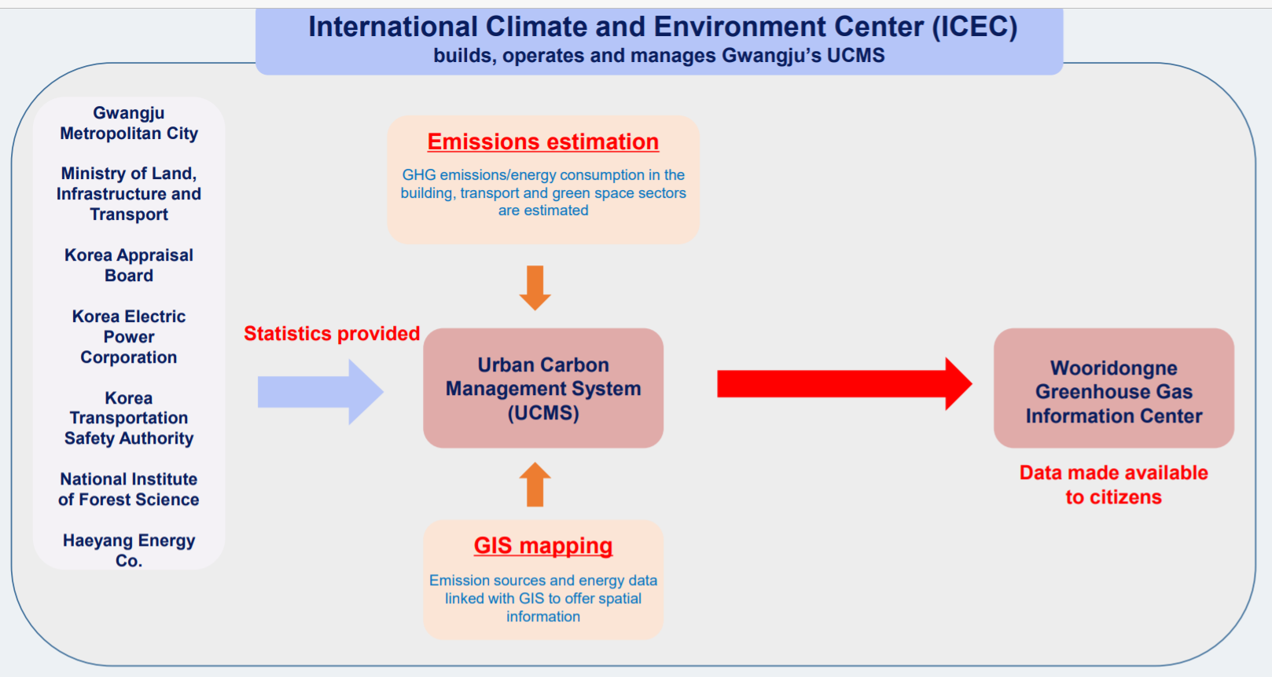

    - Gwangju city also introduced the Carbon Bank Programme in 2008, which provided subscribers with carbon points to promote low carbon lifestyle in consumption of energy and water services. Based on the experiment of Gwangju carbon credit system, the Ministry of Environment set a nationwide carbon credit system in 2014, which played a key role in GHG reduction at individual household level in the ROK.
    - The case of Gwangju is included in the comparative Study on Low Carbon City Policies in China, Japan and the ROK (see annex), which will provide a good reference for the upcoming workshops for the selected cities of the Russian Federation and Mongolia.
    - Ulan-Ude and Irkutsk, the Russian Federation: As follow-up to the SOM-23, the Secretariat commenced the preliminary discussion with the Baikal Institute for Nature Management Siberian Branch of the Russian Academy of Sciences (BINM SB RAS) to co-organize a Low Carbon City Workshop in Ulan-Ude, tentatively in May 2020. Due to the COVID-19 pandemic, the plan to organize a face-to-face meeting was postponed to a later date. As an interim activity, a virtual workshop is proposed for late 2020, to share the preliminary overview of the status of low carbon city development in Ulan-Ude and Irkutsk inviting some international participants. The discussion at the workshop can feed into a full-fledged workshop planned to be held in Ulan-Ude afterwards.
    - To support the virtual workshop, the BINM SB RAS has initiated its preliminary review of the cities as follows.
Key policies at national level
    - The Federal Law No. 172-FZ of 28 June 2014 (amended on 18 July 2019) on Strategic Planning in the Russian Federation determines the goals and objectives of municipal management and socio-economic development of a municipal entity for a long-term period. However, the strategic planning system of the Russian Federation currently does not address the detailed development of low-carbon cities. The Climate Doctrine of the Russian Federation, approved by the Decree of the President of the Russian Federation as of 17 December 2009 № 861-rp, defines the system of views on the purpose, principles, content and ways of implementation of the unified state policy. In late March 2020, the government released its draft long-term strategy for diversifying economic development and reducing greenhouse gas emissions by 2050. The baseline scenario for this strategy envisages a large-scale increase in the energy efficiency of the Russian economy, a full balance of forest reproduction, and an expansion of the area of forest protection. In addition, following the adoption of the federal “Clean Air” project, as part of the national “Ecology project”, overall reduction of emissions from transport, heat and power generation plants and industrial enterprises are expected to reduce by 20 percent by 2024.
Key policies at Ulan-Ude and Irkutsk
    - The city council of Ulan-Ude approved the “Strategy of Social and Economic Development by 2035” in December 2018. The strategy defines the goals, strategic priorities, directions of activities aimed at sustainable improvement of living standards and quality of life, and development plan of the city economy. Since 2009, the city of Ulan-Ude has been annually included in the priority list of Russian cities with high levels of air pollution. In this connection, a project on reduction of air pollution is being developed. The main goal of this project is to radically reduce air pollution in Ulan-Ude agglomeration, including the reduction of at least 35 percent of total air pollutant emissions.
    - The Strategy for Socio-economic Development of the City of Irkutsk by 2030 was developed based on the three-prolonged concept of developing the city as a diversified, balanced economy, with comfortable environment and steady increase in the life quality of the population. Approved by the city council in February 2018 (No. 006-20-440662/8), the Strategy aims to improve the quality of life on the population by ensuring social needs and comfortable living conditions. To achieve these goals, a package of municipal programmes was developed and adopted, including inter alia (a) energy saving and improving energy efficiency by 2021, (b) development of the transport system, (c) improving the quality of management of municipal property and land, and (d) the rules of landscaping.

- FUTURE NEA-LCCP ACTIVITIES
    - The secretariat plans to continue its follow-up on the proposed activities supported by SOM-23, including peer review, focusing on the nominated cities in Russian Federation and Mongolia.
    - The activities undertaken by the NEA-LCCP found uneven capacity of cities to address low carbon city development with competing priorities and limited resources and capacities. Those findings suggest the need for cities to explore the policies which embrace co-benefits between climate action and the economy, and between GHG mitigation and air quality improvement.
    - NEA-LCCP is thus expected to strengthen its role in connecting the experiences and expertise of local governments in the relevant fields. In this context, enhanced collaboration and cooperation with existing initiatives and regional networks on GHG mitigation and air quality improvement will be sought in implementing future activities.
    - While the past activities focused on those cities which have actively pursued low carbon city development and facilitated exchange of experiences and discussion for improvement, future activities may also give more weight on cities which are in the process of developing low carbon city policies. The Secretariat will explore how best to support such cities to effectively participate and benefit from LCCP activities, including the possibility to conduct cross-sectoral study on selected cities, subject to the availability of resources.

ISSUES FOR CONSIDERATION

    - The Meeting may wish to request member States to guide and express their view on the acitivies in the coming years.
    - The Meeting may further wish to request member States to guide the NEA-LCCP and support its activities, including through rendering additional resources and proposing potential projects to be implemented under the Platform.
……..

https://rmi.org/wp-content/uploads/2017/12/RMI_City_Peaking_Decarbonization_Handbook.pdf
http://www.env.go.jp/en/earth/cc/2050_zero_carbon_cities_in_japan.html
Further information on the workshop is available at http://www.neaspec.org/article/international-consultation-workshop-gwangju%E2%80%99s-low-carbon-development-policy-and-practice

