NEASPEC/SOM(24)/2
Distr.: Limited
10 September 2020

UNITED NATIONS
ECONOMIC AND SOCIAL COMMISSION FOR ASIA AND THE PACIFIC
Twenty-fourth Senior Officials Meeting (SOM) of NEASPEC
12-13 October 2020
Virtual

REVIEW OF PROGRAMME PLANNING AND IMPLEMENTATION
(Item 5(b) of the provisional agenda)
Nature Conservation in Transboundary Areas in North-East Asia

Note by the Secretariat

CONTENTS
I. BACKGROUND 2
II. CONSERVATION OF BIG FELINE SPECIES 4
III. CONSERVATION OF MIGRATORY BIRDS AND HABITATS 7
IV. ISSUES FOR CONSIDERATION 11

- BACKGROUND
- Following the adoption of the NEASPEC Nature Conservation Strategy at the SOM-12 in 2007, NEASPEC has implemented projects on the conservation of its six flagship species including three feline species (Amur tiger, Amur leopard and Snow leopard) and three migratory bird species (Black-faced spoonbill, White-naped crane and Hooded crane) in connection with the overall goals of the Strategy. That is to contribute to biodiversity conservation strategy of, promote transboundary and intergovernmental cooperation on, and enhance coordinated mechanisms for the target species and their habitats. Considering the two groups of flagship species, the NEASPEC work in the area of nature conservation has taken a two-track approach for each group.
Conservation of targeted feline species
- The project “Study on Transborder Movement of Amur Tigers and Leopards using Camera Trapping and Molecular Genetic Analysis”, which was implemented during 2014-2016, generated new information on the patterns of cross-border movements of Amur tigers and leopards and presented specific areas for transboundary cooperation as presented to the SOM-21 and SOM-22. The project was a significant milestone in transboundary cooperation as biological samples and captured images of the concerned species were exchanged across the Sino-Russian border for the first time and were utilized for joint analysis and comparative study.
- Following to the recommendations of the study, the Secretariat facilitated national experts and member Governments on the follow-up projects through the NEASPEC Consultation Meeting on Transboundary Nature Conservation held in February 2018, SOM-22 in October 2018 and the Workshop on Transboundary Conservation of Big Cat Species in North-East Asia in July 2019.
- Noting the progress towards institutionalizing transboundary cooperation, including a memorandum of understanding (MOU) between the Administration of the Northeast China Tiger and Leopard National Park (TLNP) of China and the Land of the Leopard National Park (LLNP) of the Russian Federation in 2019, the Workshop on Transboundary Conservation of Big Cat Species in North-East Asia was jointly organized by NEASPEC Secretariat and the National Forestry and Grassland Administration (NFGA) of China in Harbin in July 2019. The workshop was held in conjunction with the International Forum on Tiger and Leopard Transboundary Conservation, which adopted the Harbin Consensus on Strengthening Cooperation in Transboundary Conservation of Tigers and Leopards. The NEASPEC-NFGA joint workshop further elaborated the proposals presented at the SOM-22 and discussed how to develop a platform for transboundary cooperation in North-East Asia. During the workshop, the Government of the Russian Federation indicated the possibility of providing financial contributions to the follow-up NEASPEC projects.
- Subsequent to the workshop, three project proposals were developed by experts of China, Mongolia and the Russian Federation and presented to the SOM-23 in 2019, focusing on (1) Sino-Russian Transboundary protected area in the East Manchurian area for Amur tigers and leopards, (2) Feasibility study of transboundary cooperation between neighboring protected areas in Lesser Khingan mountains for Amur tigers, and (3) Study of migration of snow leopard along the Mongolian-Russian border. These proposals were endorsed by the SOM-23, with reservation for the first project proposal for further internal approval process.
Conservation of migratory birds and habitats
- Based on eight scoping surveys in all member States and two joint studies carried out in transboundary areas in the Korean Demilitarized Zone (DMZ) and the Dauria International Protected Areas (DIPA) in 2014-2016, the project “Conservation and Rehabilitation of Habitats for Key Migratory Birds in North-East Asia” identified main factors threatening the habitats such as (a) loss and degradation of habitats due to climate change, (b) change of water regime, (c) on-going development projects, and (d) human interference. The project further confirmed that the role of the flagship species in connecting multiple countries into one ecologically borderless community. Their ecological characteristics have significant potentials in bringing multilateral actions to conserve wider habitats and biodiversity. The project also suggested that the current protected areas are no longer adequate to conserve the concerned species, and that the key habitats in the subregion were not properly protected by the domestic policies in the surveyed areas.
- Based on country reports submitted by experts from China, Mongolia and the Russian Federation, and supplemented by field studies in DIPA in 2017, a joint study on “Connectivity Conservation and Transboundary Cooperation in North-East Asia” with the Korea Environment Institute was carried out to analyze the different stages of cooperation among transboundary habitats in DIPA, with a focus on the governance of the DIPA through its Joint Commission and associated DIPA Working Group. The study provided information on the habitat changes and examined the state of biodiversity and the socio-economic and environmental pressure faced by DIPA and the neighboring areas. The project proposed to establish a “North-East Asia Transboundary Protected Areas Network” to ensure the long-term conservation of most threatened species and valuable landscapes in the subregion, and suggested to carry out a joint research on the transboundary areas in the Tumen River Estuary as a follow-up project.
- Following to the outcomes and suggestions of the previous projects, member States at the SOM-22 and SOM-23 considered strengthening the coordination among protected areas located along or near the national boundaries, including through creating a transboundary protected area, such as transboundary Ramsar site involving the Rason Migratory Bird Reserve in the DPRK, the Khasansky Nature Park in the Russian Federation, and the wetlands in Jingxin and Fangchuan National Park in China in the Tumen River Estuary as a concrete example. Member States generally welcomed the proposal and supported the plan including surveys and study visit in the proposed sites at the Tumen River Estuary.

- CONSERVATION OF BIG FELINE SPECIES
- Further to the approval by the SOM-23, the Secretariat prepared a project document under the title of “Transboundary cooperation on the conservation of Amur tigers, Amur leopards and Snow leopards in North-East Asia” funded by the Russian Federation. The project consists of three components (see Table 1):
    - Project component 1: Transboundary cooperation between the Northeast Tiger and Leopard National Park (TLNP) of China and the Land of the Leopard National Park (LLNP) of the Russian Federation to conserve Amur tigers and leopards
    - Project component 2: Transboundary cooperation between neighboring protected areas in Lesser Khingan Mountains to conserve Amur tigers
    - Project component 3: Assessment of the current status of two snow leopard subpopulations in Transboundary are between Mongolia and the Russian Federation

Table 1 Overview of project components
Project component |  | Component 1 | Component 2 | Component 3
Implementing period |  | - Jan 2021 – Dec 2022 (suggested) | - July 2020 – June 2021 | - May 2020 – March 2021
Implementing partners |  | - LLNP | - Feline Research Center (FRC)  - WWF Russia | - Irbis Mongolia Center  - WWF Russia
Budget |  | - USD 96,000 | USD 50,000 | USD 50,000
Target areas |  | TLNP and LLNP | Lesser Khingan Mountains | Chikhachev ridge and Eastern Sayan ridge
Target species |  | Amur tiger & Amur leopard | Amur tiger | Snow leopard
Objective |  | Enhance the collaboration between two national parks; and create the condition for the establishment of a Sino-Russian Transboundary National Park (“Land of Big Cats”) | Enhance collaboration between the existing bordering PAs; and create conditions for the establishment of a new national park in Russia and the expansion of the bordering PAs in China | Assess the current status and identify individual snow leopards in the transboundary areas between Mongolia and the Russian Federation, by utilizing modern methodologies
Key Activities | Desk research | - Assessment of national legislation of China and Russia for PAs and TBPAs;  - Analysis of existing TBPAs;  - Preparation of a basic unified geographical map of projected TBPA and its adjacent territories;  - Development of unified classification of habitats and preparation of habitats map of the projected TBPA | - Assessment of national legislation and protection regime across the target area;  - Environmental and socio-economic analysis; and  - Production of a joint geographical map of the target area | Comparative study of camera trap data collected in the Mongolian-Russian border to identify snow leopard individuals and their transboundary movement
 | Field study | - | Winter census on Amur tigers and their prey in the target area | Camera trapping using modern survey methodologies (mobile app developed in 2018)
 | Capacity building/  awareness-raising | - Coordination to establish a unified information and analytical system for information sharing  - Data exchange of up-to-date status on target species  - Training and workshop for local field staff  - Joint brochure in English/Chinese/Russian | Brochure in English/Chinese/Russian | - Training of national park admin staff on camera traps and modern survey methodologies
Expected outcomes |  | An analytic report including policy recommendations to establish the “Land of Big Cats” | A project report including policy recommendations and follow-up phases to develop a joint monitoring system and management plan | A project report including analysis of camera trap data and priority action plans for follow-up phases

- Having the project document approved at the end of 2019, the Secretariat has closely communicated with potential implementing partners to discuss details of each project component and its activities and issued four Letter of Agreements (LOAs) for project component 2 and 3 (see Figure 1).

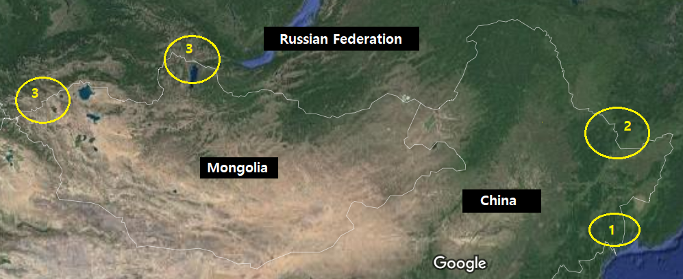
Figure 1 Target study areas of the project
** Note/ 1. TLNP + LLNP; 2. Lesser Khingan Mountain areas; and 3. Chikhachev ridge (left) and Eastern Sayan ridge (right)
- Whilst the internal approval process for TLNP to join the project component 1 as an implementing partner has been stalled, LLNP suggested developing one single LOA which covers all planned activities both in China and the Russian Federation, in order to avoid any further delay. Based on the MOU (2019) and bilateral communications between TLNP and LLNP, information sharing and joint efforts towards establishing the “Land of Big Cats” are to be continued, which are key factors for successful implementation of the project component 1. Decision has not been made yet on whether to issue LOAs with TLNP and LLNP, respectively, as planned initially; or to change the plan to issue single LOA with LLNP and, if needed, identify experts who can supplement any missing gaps to ensure the implementation of all planned activities.
- The project component 2 has started since late July 2020. Due to travel restrictions caused by COVID-19 pandemic, FRC and WWF-Russia started feasibility studies on Lesser Khingan Mountains first to assess existing protected areas as well as national legislations and protection regime on protected areas. Winter census on Amur tigers and their prey will be conducted in early 2021, and a project report including policy recommendations and follow-up plans for establishing a transboundary protected area in the target area will be prepared in mid- 2021.
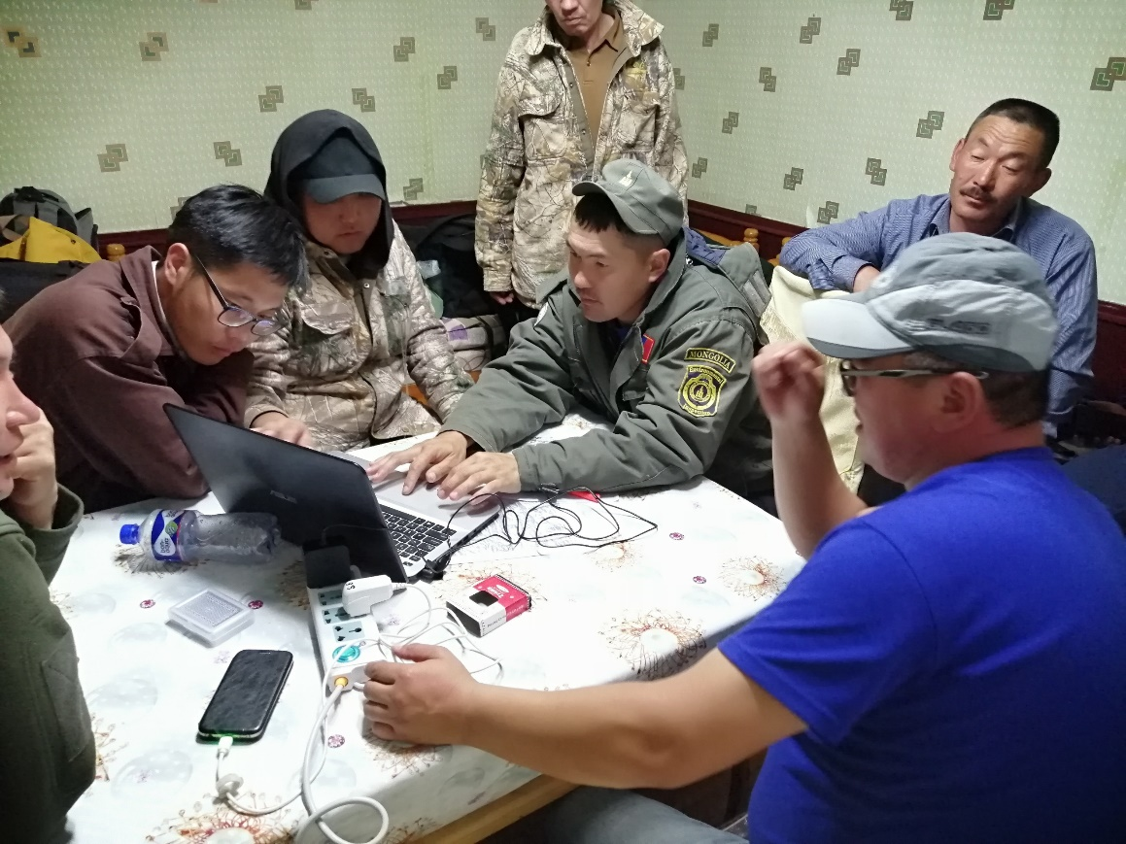
- The Project component 3 has started since mid-May 2020. Upon the agreement, two implementing partners organized inception meetings, respectively, to train experts on how to set up camera traps in the field and use the standardized snow leopard monitoring application. The mobile application was originally developed in Russian language and is now available both in English and Mongolian. Camera traps have been set up in target areas, and data will be collected and analyzed by the end of 2020. A project report including comparative analysis of camera trap data and priority action plans for a follow-up project will be presented in March 2021.
(Left: training on mobile monitoring application/ Right: camera trap installed in the field)

- CONSERVATION OF MIGRATORY BIRDS AND HABITATS
- Wetlands in the lower Tumen River area is a biodiversity hotspot in North-East Asia, representing significant ecosystem and socio-economic values. However, to date there has been no systematic communication and cooperation among the range countries (i.e. China, the DPRK and the Russian Federation) on wetland conservation and their sustainable use (see Figure 2).
- Following to the field survey result and recommendations in the Rason Migratory Bird Reserve, the DPRK, in 2014, and the discussions at SOM-22 and SOM-23, the Secretariat has worked with three national experts (two from China and one from the Russian Federation) to develop a preliminary study to review the conservation status of the targeted sites, and evaluate the feasible steps towards strengthening and institutionalizing the transboundary cooperation among the protected wetland areas in the Tumen River Estuary.

Figure 2 Wetlands in the Tumen River Estuary
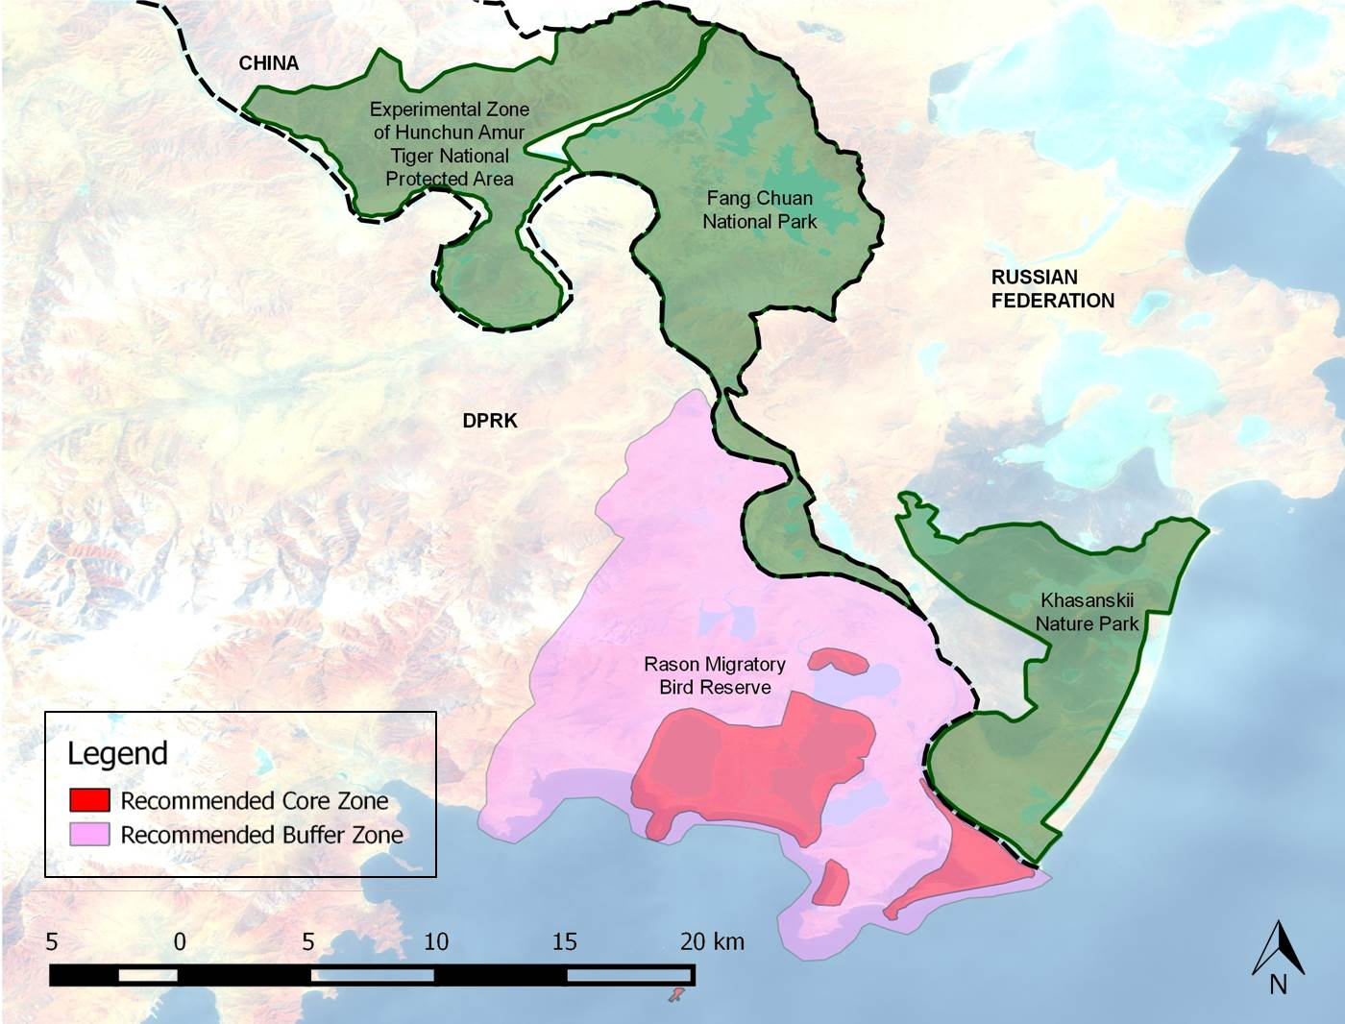
(Source: Rason Migratory Bird Reserve: Birds and Habitats, NEASPEC, 2014)
- The study examined the ecosystem integrity in the Tumen River Estuary and concluded that the ecosystem in Tumen Estuary presents the same biota via multiple connections in three countries, and that the wetlands complex is distributed as separate waterbody with channelized linkages. Hydrologically, the Jingxin and Fangchuan wetlands in China are floodplain wetlands such as oxbow lakes and plain reservoirs, whereas the wetlands in Khasansky in the Russian Federation and Rason in the DPRK consist of both freshwater and brackish water lakes that are affected by marine process. Biologically, there are aquatic fauna and flora connections among the water systems in these wetlands, and that waterbirds can easily fly across the delta region in hourly time. Ecologically, any change in any country in the area may affect the landscape pattern, hydrologic processes and biological attributes, particularly migratory waterbirds forage, of the roost and breed sites in different pieces of wetland habitat across the nation boundaries. All these connections are under interventions of human activities and will influence human through ecological feedbacks (see Figure 3).
Figure 3 Tumen Delta Ecosystem Feedback
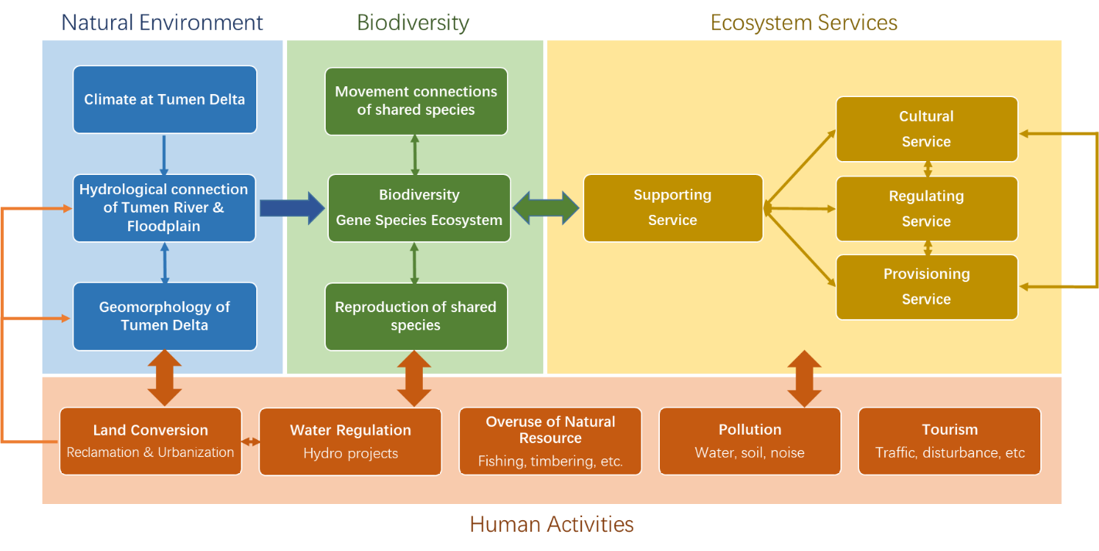

- The study concluded that Tumen River and associated wetlands play important roles for regional sustainable development, and there is an urgent need to establish transboundary conservation mechanism. As agriculture and tourism are the key economic drivers for the Jingxin and Fangchuan wetlands in China, eco-tourism such as through the form of a “Swan Festival” was considered by the authority of Rason city, the DPRK, could facilitate the conservation and sustainable use of the wetlands. As for the Russian site, the main economic emphasis in the local development plan is placed on its role as an international transport and logistics corridor, though the main transport and logistics centres are located outside the wetland area and do not directly affect the area. There is a serious demand for the land allotments adjacent to Tumen wetlands with the prospect of developing infrastructure for tourism. The study also noted various challenges faced by the area, such as the lack of capacity on wetland conservation and management in all three countries, lack of joint monitoring and management on bird species, water, soil and other elements, and insufficient understanding on ecological process and future trends.
- Initially included in the provincial-level Hunchun Nature Reserve, the main part of the Jingxin wetland was excluded from the Reserve in 2005, which recently was promoted to the national level. In the same year, Fangchuan National Scenic Park was established under the management of Hunchun municipal government, covering most part of the downstream wetlands of Tumen River. The Khasansky Nature Park has received a low protection rank in the system of protected areas of the Russian Federation and is subject to regional government legislation. The international significance of the site was recognized by the Russian government, but it has been placed in the shadow Ramsar list with the prospect of being transferred into the actual list (see Table 2).

Table 2 Protected wetlands in Tumen River Estuary
Country | Targeted sites | Status | Area (hectare) | Coordinates
DPRK | Rason Migratory Bird Reserve  (Rason Special Economic Zone) | Ramsar site (designated in 2018) | 3,525.7 ha | 42°20'N 130°35'E
China | Fangchuan National Scenic Park  (Yanbian Korean autonomous prefecture) | National scenery area (2002) | 1,416.13 ha  (areas of lakes: Qi&Badaopaozi, Wudaopaozi, Sandaopaozi) | 129°52′00″--131°18′30″E, 42°25′20″--43°30′18″N
 | Jingxin wetland  (Yanbian Korean autonomous prefecture) | Not included in any type of protected area | 8,000 ha
Russian Federation | Khasansky Nature Park  (Primorsky Krai) | Prefectural level protected area established by the Primorsky Krai Administration (1997) | Main (southern) cluster:  9,885.8 ha | 130°38′25″--130°47′25″E, 42°18′70″--42°28′25″N
 |  |  | Maloye Mramornoye Lake (northern):  83.3 ha | 130°46′47″E, 42°33′15″N

- An Expert Group Meeting on Promoting Transboundary Cooperation among Protected Wetlands in the Tumen River Estuary was organized in May 2020 to review the key findings and recommendations of the study, and deliberate on the way forward to promoting transboundary cooperation among countries and partners. The meeting was joined by government officials, national experts, and representatives of the Ramsar Convention Secretariat and its training center. Participants developed tangible ideas and activities, including to establish a coordinated mechanism among range countries. Noting the need to incorporate information on local development plans and social-economic context, the meeting suggested drawing a tentative boundary for the transboundary protected areas in the Tumen River estuary and developing a joint species list to synchronize information. The national focal points of the Ramsar Convention of China and the Russian Federation also joined the meeting and indicated the interest and commitments for further consultation on possible joint conservation.
- The report of the preliminary study on transboundary cooperation among protected wetlands in the Tumen River estuary will be finalized by December 2020 through a peer review process, and to incorporate a joint species list among the targeted wetlands in the lower Tumen area.
- ISSUES FOR CONSIDERATION
- [Conservation of tigers and leopards] The Meeting may wish to request member States to provide their views on the ongoing activities including the modality for the project component, and share the information of relevant bilateral and multilateral processes pertaining to the project.
- [Conservation of migratory birds and habitats] The Meeting may wish to invite member States for their views and decision on the proposed activities for institutionalizing the transboundary cooperation in the Tumen River estuary; to nominate national focal points/ experts for further consultations; and to express their interest in hosting a workshop/ Expert Group Meeting in the first half of 2021.
- The Meeting may wish to invite member States to express interests in organizing NEASPEC’s outreach activities during the 15th meeting of the Conference of the Parties to the Convention on Biological Diversity (CBD COP-15) in May 2021, China, and the 14th Meeting of the Conference of the Contracting Parties to the Ramsar Convention on Wetlands (COP14) in November 2021, China.

………

http://www.neaspec.org/sites/default/files/Publication_SavingNatureConservation_2.pdf
The project report is available at http://www.neaspec.org/sites/default/files//2018_12_17_UNESCAP_%ED%98%B8%EB%9E%91%EC%9D%B4.pdf
Project report: http://www.neaspec.org/sites/default/files//UNESCAP_Migratory%20Birds.pdf
Project report: http://www.neaspec.org/sites/default/files//NEASPEC-KEI%20joint%20report_for%20web_1.pdf
Rason Migratory Bird Reserve Survey Report (2014) http://www.neaspec.org/sites/default/files/Rason%20migratory%20bird%20reserve_birds%20and%20habitats.pdf
National Report on the Implementation of the Ramsar Convention on Wetlands, Ramsar Convention, 2015

